



**Al Imam Mohammad ibn Saud Islamic University**

**College of Computer and Information Sciences**

**Information Systems Department**

**Web Programming Application**

|  |  |  |  |
| --- | --- | --- | --- |
| **ID** | **NAME** |  | **Section #** |
|  |  |  | **171** |
|  |  |  | **171** |
|  |  |  | **171** |

***Table of contents***

|  |  |
| --- | --- |
| 1- | Introduction….3 |
|  | Conclusions….4 |
| 2- | *Welcome*….5 |
| 2- | *Read About Us*….6 |
| 3- | *Contact US*….7 |
| 5- | *World Cup 2018*….8 |
| 6- | *Players Registration….9* |
| 7- | *Players List* ….10 |
|  | Top three teams ….11 |
|  | Conclusions….12 |

1. ***Introduction***

**In this report we will introduce our web site that we have developed that has some features**

**We have developed a welcome page and a contact us page with the details of the user and more page such as Top Three Teams. Also there is a background image for the world cup that is under construction then we have finally implemented a webpage for players registration using PHP and MySQL database.**

***2- Home***

**Just a web page conent the world cup 2018 logo right in the center.**



***2- Welcome***

**Welcome page has a Gif image as a background and a sound the plays automatically for welcoming the user.**



***3- Read about US***

**Read About US page has images and CV for every team member that has information about everyone in our team members.**

***4- Contact US***

**Contact US page has a required fields for the contact (name, city and subject)**

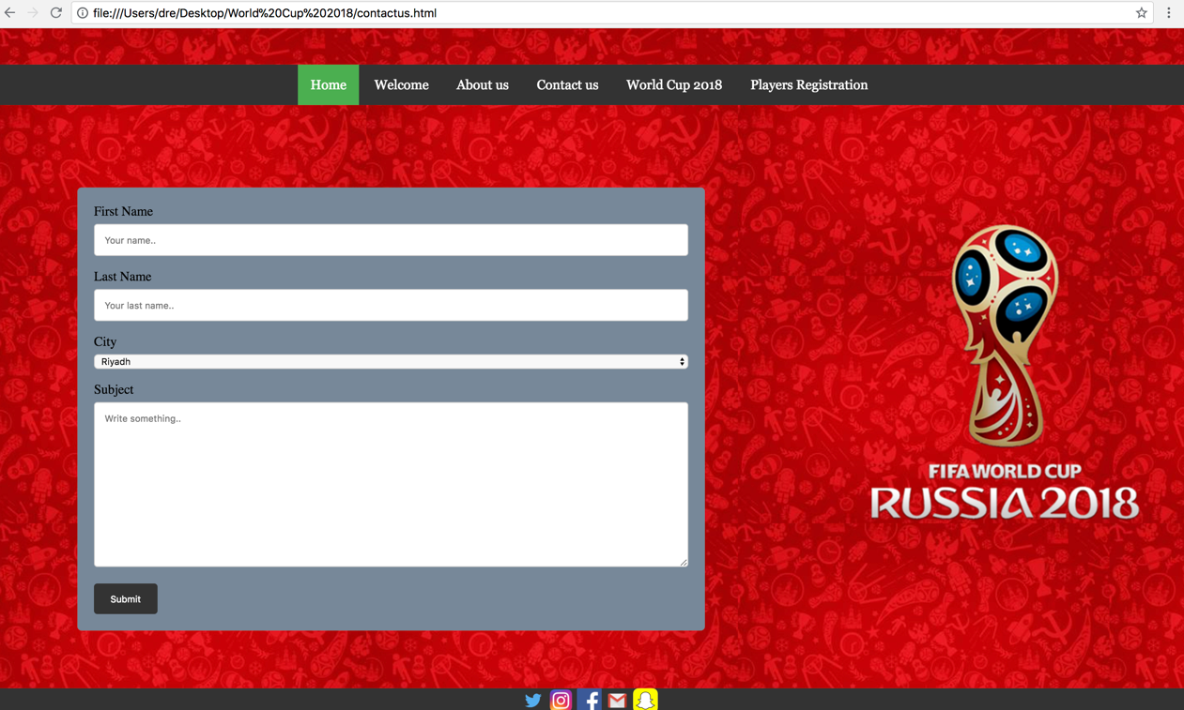

***5- world cup2018***

**world cup page has an images for show that this page is under construction.**

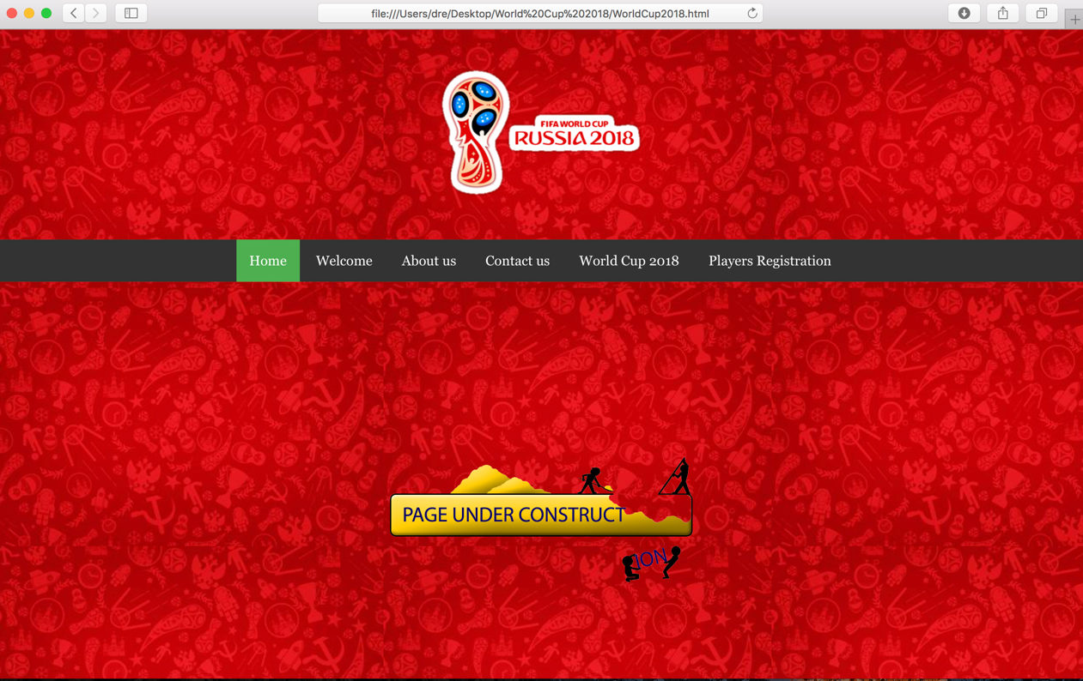

***6- Players Registration***

**Registration page content few inputs fields for the user the entire the player’s name (First name, last name) plus his age and finally his total goals. After then the user can either submit the form to the database or clear it.**



***7- Players List***

**Player list is page with only two elements.**

1. DropDownMenu **to select the team.**
2. Table **to show the user a list of players belong to the selected team.**
3. **Extra:  
   Highest goals will be colored in Red**



***8- Top three teams***

**Here u will see a DropDownMenu with three Flags. And if you hover on one of them. You shall see the name. Then is clicked on a flag, you will have their map as background, and three top players with their names. Also at the bottom you can find a small paragraph about their achievements.**



***9- Conclusion***

**Finally we have developed our website that has many things that we have applied in our web pages programming course like PHP, JavaScript language and HTML, CSS for the layout.**

**And more importantly the MySQL database.**

**We have implemented eight pages like the welcome page, read about us page, players list, contact us page and a registration page, top three teams.**

**All of the previous pages we have applied some of the features from the course to apply the assignment tasks like background image, text based and image menu and forms all of these features have built our nice website that we have discussed before.**